UNIVERSITY OF SURREY   
THE FACULTY OF ARTS AND SOCIAL SCIENCES  
Surrey Business School  
  
OPERATIONAL ANALYTICS COURSEWORK

Academic Year 2022-2023

Submission deadline: 1600 BST, Wednesday 24th May 2023

|  |  |  |  |
| --- | --- | --- | --- |
| Student URN | MSc Programme | Surname  (capitals) | First Name  (capitals) |
| 6761688 | BUSINESS ANALYTICS | Jadhav | Siddhesh Suresh |

Contents

RAPID DNA SCENARIO MODELLING 3

METHOD 3

RESULTS 4

DISCUSSION & CONCLUSIONS 15

# RAPID DNA SCENARIO MODELLING

The purpose of this report is to test Rapid DNA Forensics in order to expedite the review of the available evidence. Because detectives require time to gather operational intelligence to maximize the possibility of conviction, the goal is to deliver results in a 24-hour window.

## METHOD

The procedure and parameterization of each model are described by Hill (2023), it is a brief explanation of how I used that description to create the five scenario models. To make scenario-1 model, I used the model of current process that was provided to me. I deleted the extra Friday DNA sequencer activity and queue so I can rename the older Wednesday sequencer to new Rapid DNA sequencer. I deleted the Wednesday collect activity and que to optimize the model, then updated the visual logic (entry and exit logic) of new rapid DNA sequencer machine and apply new specs for activities which are provided by Hill (2023) in Table 3.

I made Scenario-2 model by Deleting the CSIs input evidence into system activity and queue from Scenario-1, then I change transport to lab to Courier and connecting the CSI visit activity to Courier queue by link. After connecting it to the link I modified the visual logic (entry and exit logic) in queue properties then I revised the specs of CSIs visit and Courier as per Hill (2023).

For scenario-3 I altered the number of server of CSIs visit from 4 to 1 in scenario-2 model and then modified specs of CSI visit and Courier as per Hill (2023). Similarly, I used scenario-2 model to build scenario-4 model by revising specs of lab activities as per Hill (2023). scenario-5 I build by using scenario-4 model and make same changes as I made in scenario-3.

I changed random sampling number to 542 and put the same number in Base random number set in Run trial for every model. As per instructions I run trails of 500 runs in simul8 for current process and scenario 1-5. I captured result for each simulation through result manager in Excel. I also ran one run for every scenario and extracted data of time spreadsheet in excel, Then imported that data of time spreadsheet into RStudio and analyzed it by visualization. I calculated the ROI for each scenario with the help of Hill (2023).

## RESULTS

After running simulation model for current process, it is easier to identify the various bottlenecks in the process. By referring to table 1 I can infer that the average total time in system to complete the whole process with older DNA sequencer machine is 11385 minutes and its mostly varying from 11243 minutes to 11527 minutes. The main contributor of that delay is the old DNA sequencer machine as its processing 100 sample for 2880 minutes in the process. Another contributor is CSI visit and sample collection, with average of 37.78 number of samples in its que and the average queueing time of 3764.17 in system.

After CSI visit another bottleneck, we can observe in queues are machine collect and sample preparation. They have similar average queue sizes indicating they have similar amount of sample waiting in their queue. The low and high sample counts are very close which means they have very short ranges. Another contributor for the delay is system is validation though it has very small number of average sample counts, but its average queueing time is 1122 minutes its low and high 95% is same as its average queueing time.

The delay or the average queueing time in other activities and queue is insignificant as it is causing very insignificant delay compared to above activities.

Table 1

Average total time in System and the operational characteristics of Current Process

|  |  |  |  |  |  |
| --- | --- | --- | --- | --- | --- |
| **Sr.No.** | **Simulation Object** | **Performance Measure (Average)** | **Low 95%  Sample Count** | **Average Sample Count** | **High 95%  Sample Count** |
| 1 | Queue for CSI visit and sample collection | Queue Size | 36.32 | 37.78 | 39.24 |
| 2 | Queue for Data input at station | Queue Size | 2.07 | 2.07 | 2.08 |
| 3 | Queue for Transport to lab | Queue Size | 0.00 | 0.00 | 0.00 |
| 4 | Queue for Sample prep | Queue Size | 16.35 | 16.39 | 16.43 |
| 5 | Queue for machine collect | Queue Size | 16.72 | 16.74 | 16.75 |
| 6 | Queue for DNA Machine | Queue Size | 0.14 | 0.14 | 0.14 |
| 7 | Queue for Validation | Queue Size | 6.36 | 6.36 | 6.37 |
| 8 | Queue for ID database | Queue Size | 0.01 | 0.01 | 0.01 |
|  |  |  |  |  |  |
|  |  | **(Average)** | **Low 95% (In Minutes)** | **Average  In Minutes)** | **High 95% (In Minutes)** |
| 1 | Match | Time in System | 11242.92 | 11385.23 | 11527.53 |
| 2 | Queue for CSI visit and sample collection | Queuing Time | 3623.19 | 3764.17 | 3905.15 |
| 3 | Queue for Data input at station | Queuing Time | 211.57 | 211.66 | 211.76 |
| 4 | Queue for Transport to lab | Queuing Time | 0.00 | 0.00 | 0.00 |
| 5 | Queue for Sample prep | Queuing Time | 1648.57 | 1651.40 | 1654.24 |
| 6 | Queue for Machine collect | Queuing Time | 1701.06 | 1701.51 | 1701.96 |
| 7 | Queue for DNA Machine | Queuing Time | 32.64 | 32.74 | 32.85 |
| 8 | Queue for Validation | Queuing Time | 1122.57 | 1122.59 | 1122.62 |
| 9 | Queue for ID database | Queuing Time | 1.33 | 1.33 | 1.34 |

When I run model to converge all relevant parameter it is obvious that 500 trials are not enough to converge the model. The runs required to converge the model is unconfirmed, but I can confirm that even 2000 trials are not enough to converge the models.

According to table 1 the main stages that’s causing delay in system is Old DNA sequencer machine, Queue for CSI visit and sample collection, Queue for sample preparation, Queue for DNA machine Collect and validation of the sample.

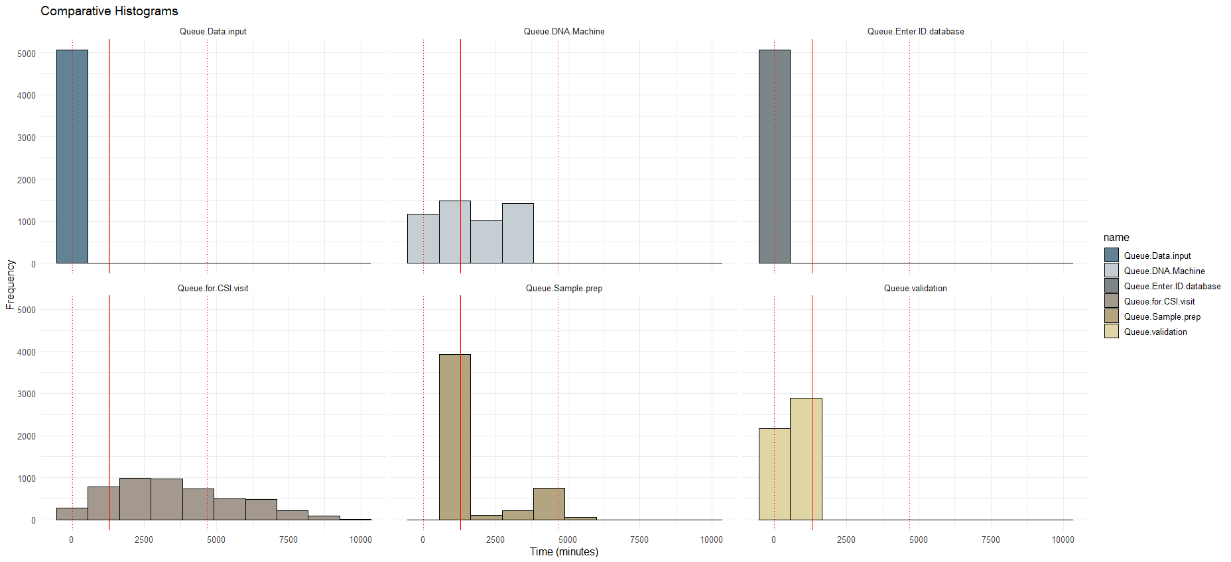

Figure01. Time distribution for each queue

Referring to the figure01 I can see that queue for CSI visit have the more variance than the any other queue which implies that the samples are in queue are experiencing the longer waiting times than the any other queue to proceed to next stage. because of high variance there is unpredictability, and it can show the bottleneck in system.

Another Queue which has high variance is queue for sample preparation and I can infer that its increasing total time in system and causing another bottleneck. Figure 1 infers that the queue for DNA machine collect which is nothing but queue for old DNA sequencer machine has the good variance which indicates the process is slow and less effective as we need results in 48 hours.

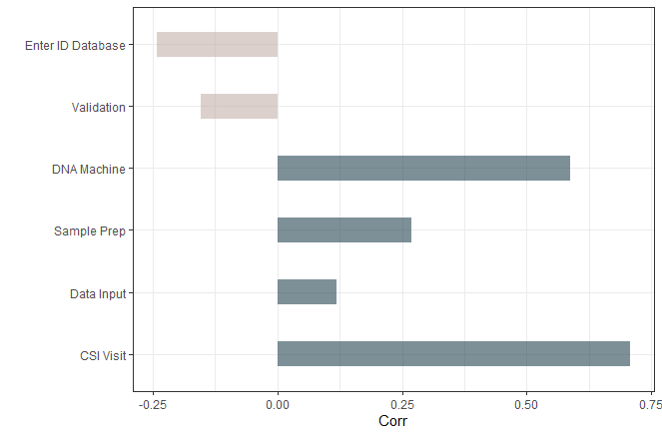

Figure02. Sensitivity analysis of the total time in the system

Inferring from the figure02 queue for CSI visit and queue for DNA Machine are showing highly positive correlation which means that because of this queues sample is spending longer duration in system. Queue for Sample prep and data input also have positive correlation which results in increase of time in system. Que for DNA sample run through ID database and validation have negative correlation with time in system which infers because of this queue the time in system is decreasing.

By examining Table 2, I can make conclusions about the distribution of time spent in each queue and determine the time that samples typically spend in each queue at the 5th and 95th percentiles

Table 2

The 5th, 95th and Average distribution for Queue of Current Scenario

|  |  |  |  |  |
| --- | --- | --- | --- | --- |
| **Sr. No.** | **Variable** | **5th Percentile in Minutes** | **Average  in Minutes** | **95th Percentile  in Minutes** |
| 1 | Queue for CSI visit and sample collection | 502.28 | 3542.15 | 7368.96 |
| 2 | Queue for Data input at station | 23.70 | 212.81 | 400.53 |
| 3 | Queue for Transport to lab | 0.00 | 0.00 | 0.00 |
| 4 | Queue for Sample prep | 868.16 | 1672.44 | 4037.14 |
| 5 | Queue for Machine collect | 54.17 | 1704.12 | 3140.63 |
| 6 | Queue for DNA Machine | 0.00 | 0.00 | 0.00 |
| 7 | Queue for Validation | 6.56 | 654.78 | 1158.80 |
| 8 | Queue for ID database | 0.00 | 1.15 | 3.39 |

Table 3

Average, Maximum and Minimum Times in System for Scenario 1-5

|  |  |  |  |  |  |  |
| --- | --- | --- | --- | --- | --- | --- |
| **Sr. No.** | **Simulation Object** | **Performance Measure** | **Low 95%  (Minutes In Queue)** | **Average  (Minutes In Queue)** | **High 95%   (Minutes In Queue)** |  |
| 1 | Scenario 1 | Average Time in System | 7203.10 | 7329.42 | 7455.75 |  |
|  |  | Maximum Time in System | 11728.67 | 11946.64 | 12164.61 |  |
|  |  | Minimum Time in System | 2802.77 | 2862.66 | 2922.55 |  |
| 2 | Scenario 2 | Average Time in System | 4903.85 | 4949.33 | 4994.81 |  |
|  |  | Maximum Time in System | 8551.30 | 8669.82 | 8788.33 |  |
|  |  | Minimum Time in System | 1786.44 | 1808.45 | 1830.47 |  |
| 3 | Scenario 3 | Average Time in System | 4097.95 | 4143.30 | 4188.65 |  |
|  |  | Maximum Time in System | 7789.85 | 7913.61 | 8037.37 |  |
|  |  | Minimum Time in System | 1134.94 | 1156.30 | 1177.66 |  |
| 4 | Scenario 4 | Average Time in System | 2555.61 | 2566.62 | 2577.64 |  |
|  |  | Maximum Time in System | 4953.43 | 4974.37 | 4995.31 |  |
|  |  | Minimum Time in System | 568.38 | 577.61 | 586.84 |  |
| 5 | Scenario 5 | Average Time in System | 865.44 | 867.77 | 870.11 |  |
|  |  | Maximum Time in System | 1658.93 | 1675.61 | 1692.29 |  |
|  |  | Minimum Time in System | 411.20 | 413.15 | 415.10 |  |

Running the models for scenario1-5 for 500 runs generates the simul8 result manager which have the average, minimum and maximum time in system which I have tabulated in the table 3. Table 3 indicates that the course correction I have done to remove bottlenecks in system is working. As the time in system is decreasing significantly, we can see the process is getting expediate and more samples can be analyzed in less time.

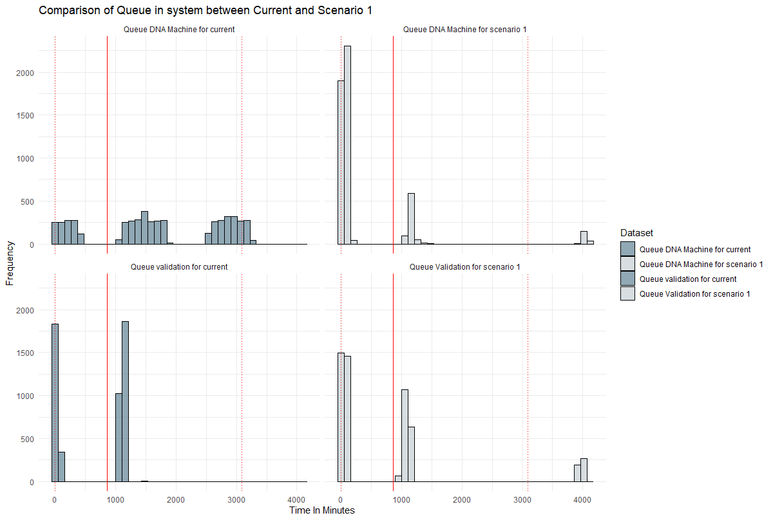

Figure03. Comparison between Current and Scenario1

In scenario-1 I changed the older DNA sequencer machine to the new rapid DNA machine which takes 2 hours to run 8 samples instead of 2 days for 100 samples. After changing the new rapid DNA machine, I can refer to figure03 to compare the distribution of variance on time in system or I am also able to see the change in frequency for the queue for DNA machine. As samples are running through queue for DNA machine more frequently than the older one, But validation still has the high variance in scenario 1 than current process.

Figure03. Comparison between Current and Scenario1

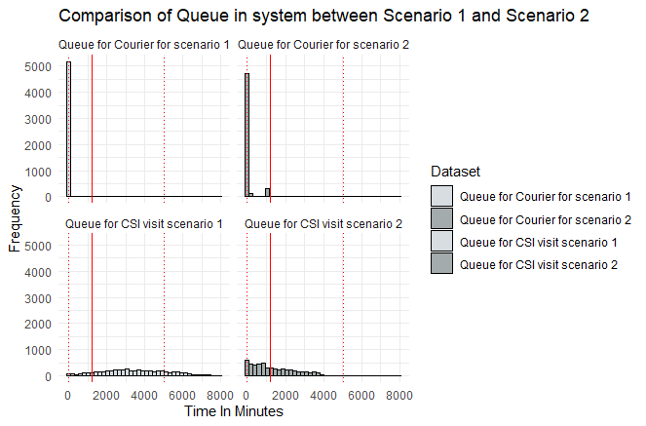

Figure04. Comparison between scenario1 and Scenario2

In scenario 2 I tried to improve system by eliminating transport to lab with faster courier service which will be available to take samples prepared from increased number of CSIs to the lab without any delay who are also working in shift parallel to CSI. With the help of figure04 I can infer that the variance in Que for CSI visit is decreased considerably. Variance in queue for courier increase in a small amount but the activity is decreasing the time in system.

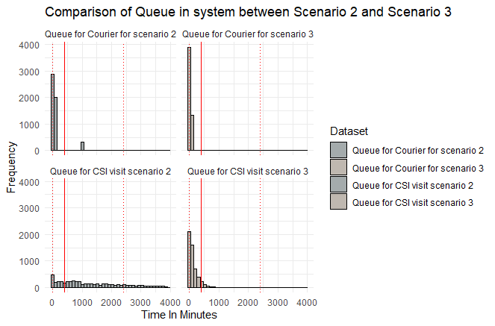

Figure05. Comparison between scenario2 and Scenario3

In Scenario 3 CSI visit and courier are working 24hours for 7 days when only one CSI is working instead 4. Still from figure05 we can see the big change in variance of the sample in queue for CSI and courier as they are decreasing in both queues.

In scenario 4 lab worker are working 24 hours for 7 days though CSIs and courier are working as per shifts as they were doing in scenario 2. I can deduct from the figure06 that all lab queues are seeing less variation than the scenario 2 with higher frequency of less time in system.

In scenario5 both lab workers, CSI and Courier are working for 24 hours for 7 days so the results would be same as per scenario 3 and scenario 4 every queue will be working seamlessly without any delay.

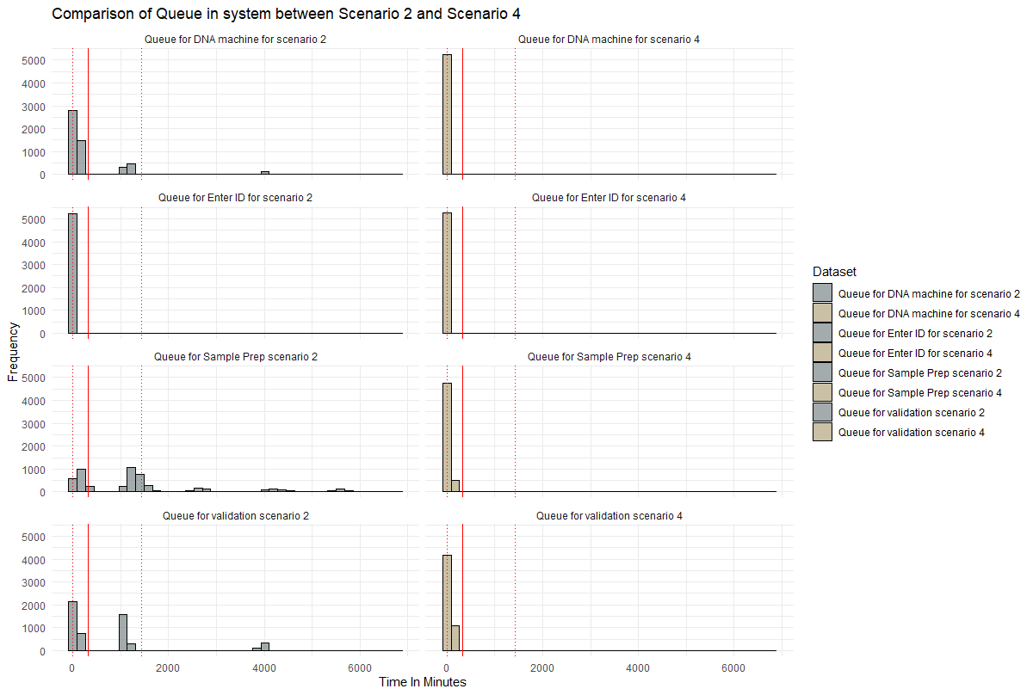

Figure06. comparison for lab queues in scenario2 and scenario 4

I changed the older DNA machine with New Rapid DNA machine so we decrease the time in activity from 2880 minutes to 120 minutes which is working in shift parallelly changed validation shift so they will work more hours than before and decrease the delay. In scenario 2 we increase CSI number from 3 to 4 and delete one extra activity to delete CSI input evidence to system activity. Put courier in process to pacify the process and decrease the time in system with instant collection and transportation, we (Hill, 2023) then change the shifts of CSI visit and Courier to as we discussed before. And the transformation of the system we can see through variance in time in system through every scenario in figure07, increasing frequency over the smaller times indicate that more and more samples are passing through the DNA sequence run through ID database are producing result faster than the before.

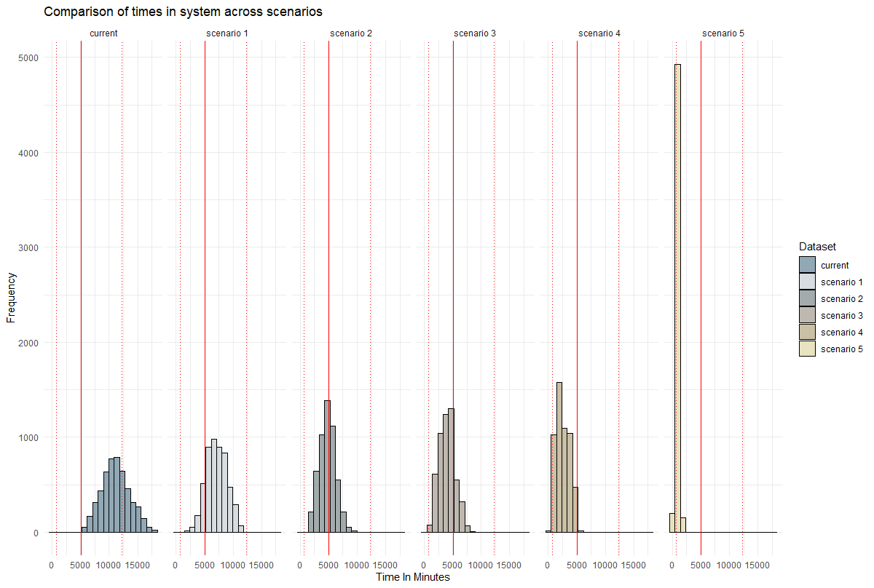Figure07. Comparison between Times in System For scenario 1-5

Table 4

ROI for the DNA forensic process and the Rapid DNA scenarios

|  |  |  |  |  |  |
| --- | --- | --- | --- | --- | --- |
| **Scenario** | **Cost per year (in millions)** | **Average Time in System  (In Minutes)** | **Average Time  in Days** | **Probability of  Arrest** | **Return of Investment (£m)** |
|  |  |  |  |  |  |
| Current Process | £5.00 | 11385.23 | 7.91 | 0.02 | £0.40 |
| Scenario 1 - Rapid DNA Machines only | £7.00 | 7329.42 | 5.09 | 0.02 | £0.29 |
| Scenario 2 - Rapid DNA + Courier | £7.50 | 4949.33 | 3.44 | 0.02 | £0.27 |
| Scenario 3 - Rapid DNA + Courier + 24 hrs CSI | £9.00 | 4143.30 | 2.88 | 0.05 | £0.56 |
| Scenario 4 - Rapid DNA + Courier + 24 hrs Lab | £9.50 | 2566.62 | 1.78 | 0.08 | £0.84 |
| Scenario 5 - Rapid DNA + Courier + 24 hrs CSI + 24 hrs Lab | £11.00 | 867.77 | 0.60 | 0.1 | £0.91 |

Table 4 and figure08 indicates the various scenarios and the Roi for them. The best scenario for ROI is scenario 5 as the return is maximum the average time in system for the scenario 5 is less than any other scenario the return is maximum for the same.

Figure08. ROI for the DNA forensic process and the Rapid DNA scenarios

Table 5

ROI for the DNA forensic process and the Rapid DNA scenarios in 48 Hours

|  |  |  |  |  |
| --- | --- | --- | --- | --- |
| Scenario | Cost per year  (in millions) | Number of samples DNA run through | Probability of Arrest | Return of Investment (In £m) |
|  |  |  |  |  |
| Current Process | £5.00 | 0 | 0.08 | £0.00 |
| Scenario 1 - Rapid DNA Machines only | £7.00 | 33 | 0.08 | £0.01 |
| Scenario 2 - Rapid DNA + Courier | £7.50 | 492 | 0.08 | £0.10 |
| Scenario 3 - Rapid DNA + Courier + 24 hrs CSI | £9.00 | 1245 | 0.08 | £0.22 |
| Scenario 4 - Rapid DNA + Courier + 24 hrs Lab | £9.50 | 3244 | 0.08 | £0.55 |
| Scenario 5 - Rapid DNA + Courier + 24 hrs CSI + 24 hrs Lab | £11.00 | 5280 | 0.08 | £0.77 |

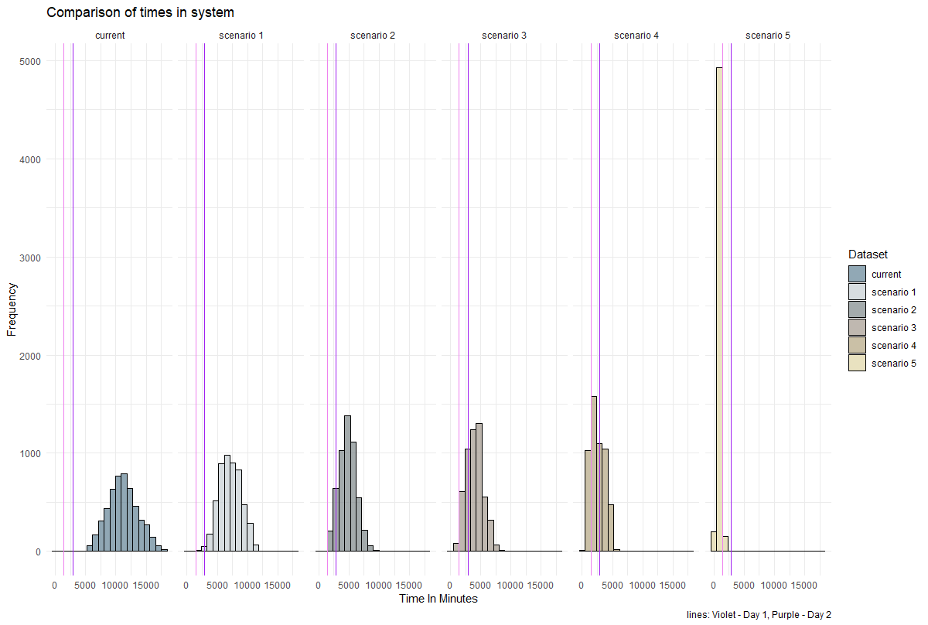

Figure09. ROI for the DNA forensic process and the Rapid DNA scenarios in 48 Hours window

From Table5 and figure08 inferring is easy as the maximum samples are running through the system in scenario 5 are more than any other scenario. As table is showing scenario 5 is also giving the best return of investment. Threshold line can indicate that we achieve 24 hours goal for getting result to convict criminals.

## 

## DISCUSSION & CONCLUSIONS

According to the results scenario 5 is the best optimal solution as we are concerned about catching the petty thieves, we should be considering arresting them in 48 hours and that can be achievable by scenario 5. Though its impossible to deploy such scenario due to cost of the human capital requirement but the results we are getting in table 05 and figure 09 its clear we have to choose scenario5.

# Bibliography

Hill, A. (2023). *Operational Analytics coursework guidance.* Retrieved from https://surreylearn.surrey.ac.uk/d2l/le/lessons/241611/lessons/2638432